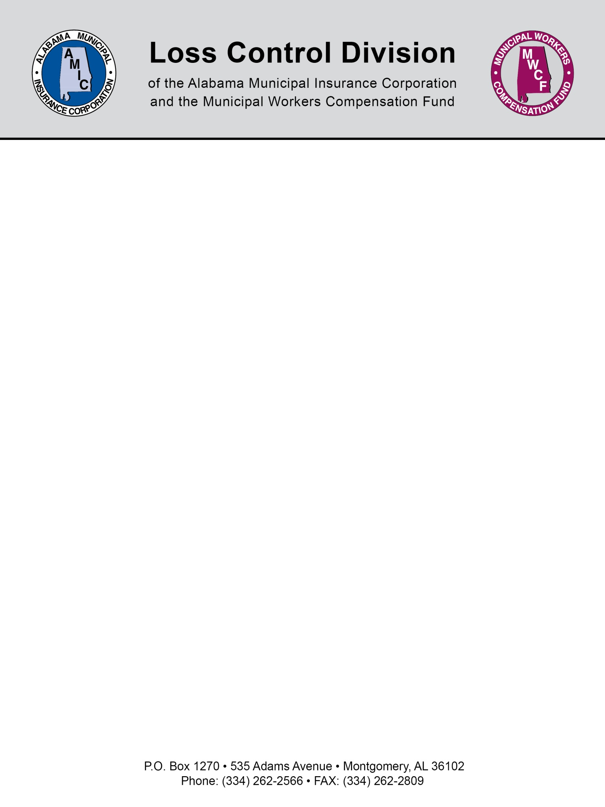

SAMPLE for Employee Declining Hepatitis B Vaccination

Hepatitis B Declination Statement*
The following statement of declination of hepatitis B vaccination must be signed by an employee who chooses not to accept the vaccine. The statement can only be signed by the employee following appropriate training regarding hepatitis B, hepatitis B vaccination, the efficacy, safety, method of administration, and benefits of vaccination, and that the vaccine and vaccination are provided free of charge to the employee. The statement is not a waiver; employees can request and receive the hepatitis B vaccination at a later date if they remain occupationally at risk for hepatitis B.

Declination Statement
I understand that due to my occupational exposure to blood or other potentially infectious materials I may be at risk of acquiring hepatitis B virus (HBV) infection. I have been given the opportunity to be vaccinated with hepatitis B vaccine, at no charge to me; however, I decline hepatitis B vaccination at this time. I understand that by declining this vaccine I continue to be at risk of acquiring hepatitis B, a serious disease. If, in the future I continue to have occupational exposure to blood or other potentially infectious materials and I want to be vaccinated with hepatitis B vaccine, I can receive the vaccination series at no charge to me.
Employee Signature:_____________________________ Date:____________________

NOTE: This document is not intended to be legal advice. It does not identify all the issues surrounding the particular topic. Public agencies are encouraged to review their procedures with an expert or an attorney who is knowledgeable about the topic. Reliance on this information is at the sole risk of the user.

Revised 8/2013

